

**Introduction to Computer Vision**

**Coursework**

**Submission 1**

**Your name HAO BAI____________**

**Student number 180223545___________**

**Question 1(a):**

Your image

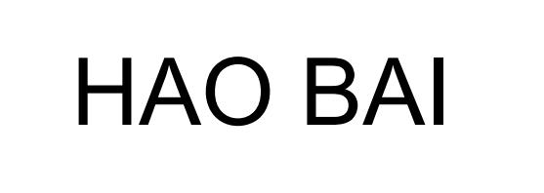

**Rotated images:**

θ = -50 deg

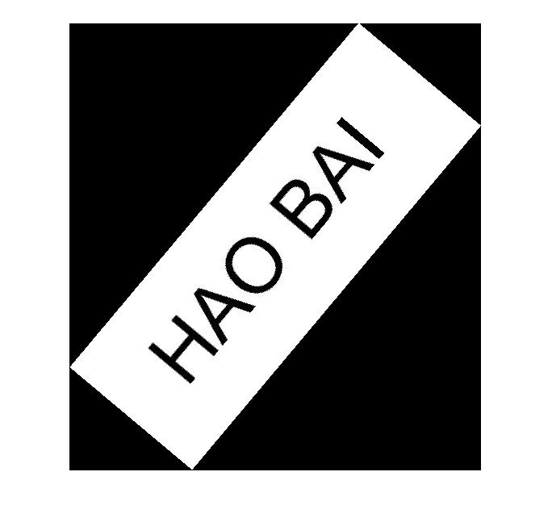

θ = 60 deg



θ = 30 deg

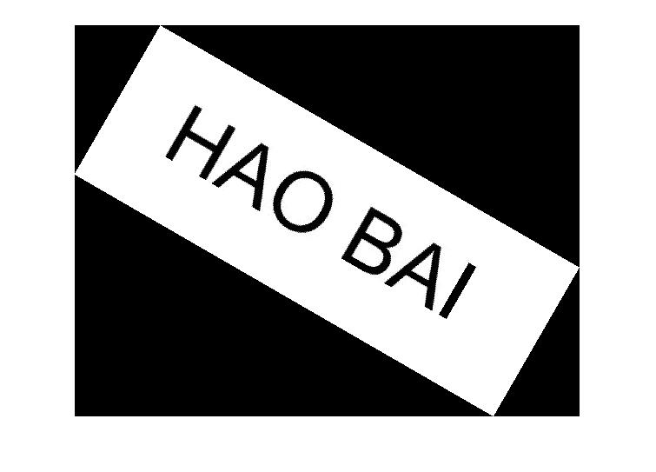

θ = 120 deg

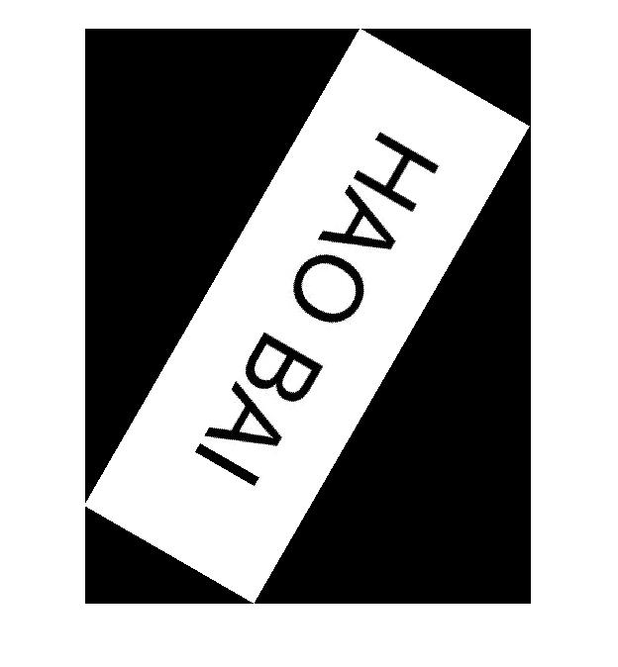

**Skewed images:**

θ = 10 deg

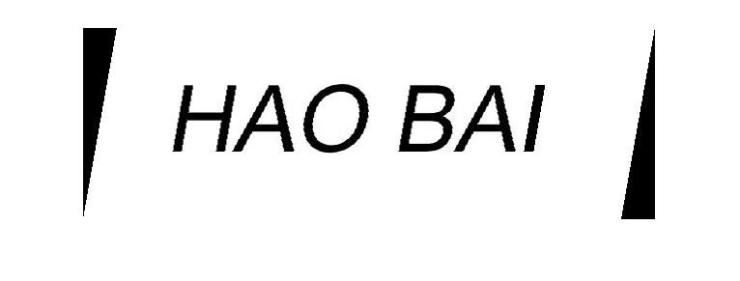

θ = 40 deg

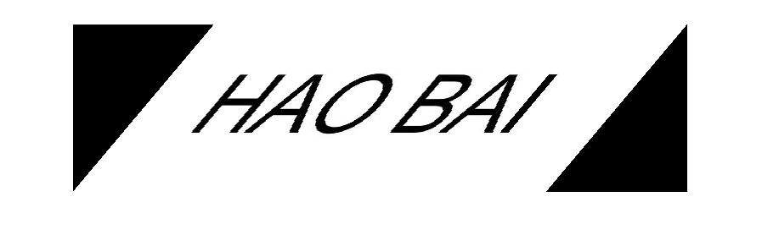

θ = 60 deg

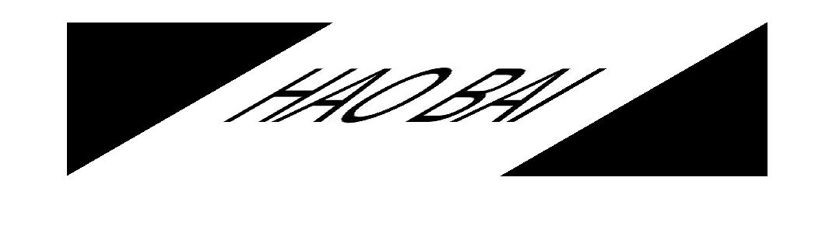

**Your comments:**

**The forward mapping is taken in this function. This function first calculates after mapping image hight and width. And create a new image.**

**Rotate:**

**New image hight = cos(theta) * Rows + Cols * sin(theta)**

**New image width = cos(theta) * Cols + Rows * sind(theta)**

**Skew:**

**New image hight =** **Rows**

**New image width = Cols + Rows * tand(theta)**

**And then find the maping point on the new image**

**Rotate:**

**Image (i, j) == new image (x, y)**

**X = (i - Rows_new/2) * cos(theta) -(j - Cols_new/2) * sin(theta)**

**Y = (j - Cols_new/2) * cos(theta) +(i - Rows_new/2) * sin(theta)**

**Skew:**

**Image (i, j) == new image (y, x)**

**y =i**

**x = j- i * tan(theta) + Rows*tan(theta);**

**After mapping all point of the orginal image, the complete rotated and skewed image can be seen in the result. Since the image needed to be shown as a rectangle, the no mapping part of the new image is set to black. The black part of the image is components of the new image**

**Question 1(b):**

θ2=50 and θ1=20 clockwise

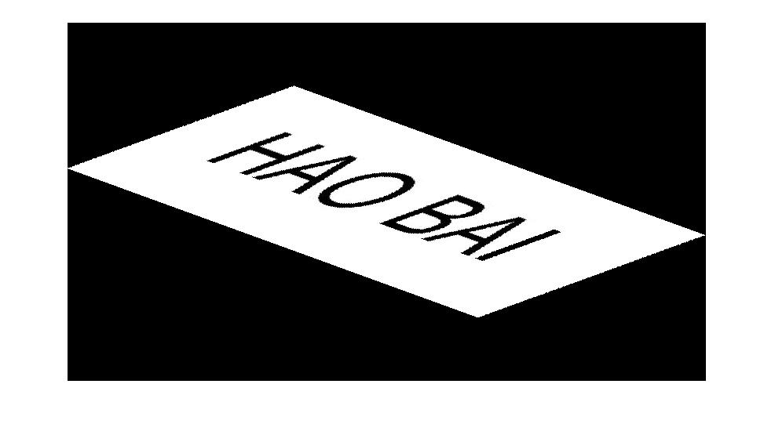

θ1=20 clockwise and θ2=50

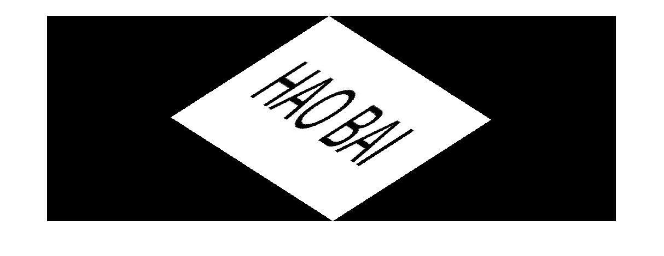

**Your comments:**

**The reason of the extra black part:**

**After the first function skew or rotate the image, the black part is a part of the result image. The second function skew or rotate is to implement changes on the result inage, not the orginal image. This caused the extra black part appeard.**

**Without black part, the shape of the image is same.**

**Reason:**

**Skew first Result image = (Rotate(Skew(image))) = (Rotate*Skew(image))**

**Rotate first Result image = (Skew (Rotate (image))) = (Rotate*Skew(image))**

**So:**

**Skew first Result image == Rotate first Result image**

**The result image without black part is same.**

**Question 2(a)**:

**Designed kernel:**

**1,1,1**

**1,1,1**

**1,1,1**

Averaged image

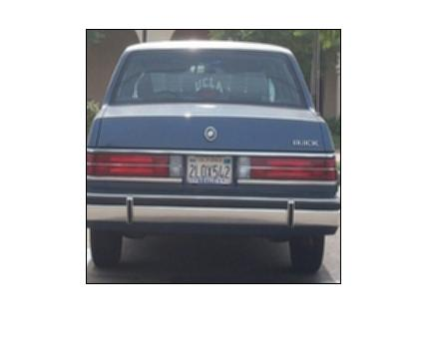

Original image

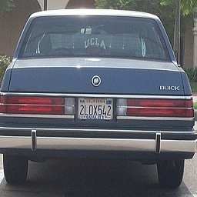

**Your comments:**

**The function is using the kernel to c**

**Function:**

**[x (k, l) **g (k, l)] **h (k, l) = x (k, l) **[g (k, l) **h (k, l)]**

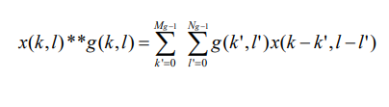

**Question 2(b):**

**Filtered image with kernel A**

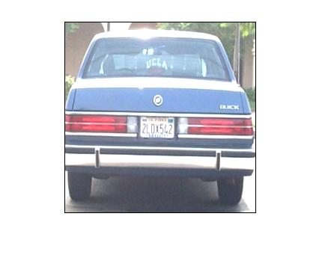

**Filtered image with kernel B**

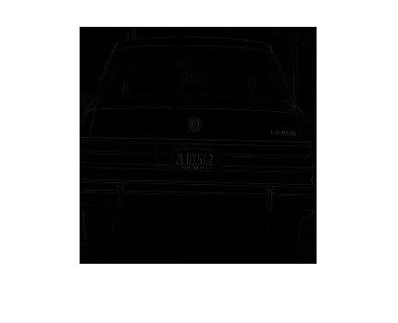

**Your comments:**

**Question 2(c):**

A followed by A

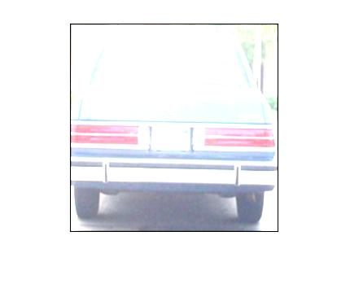

**A followed by B**

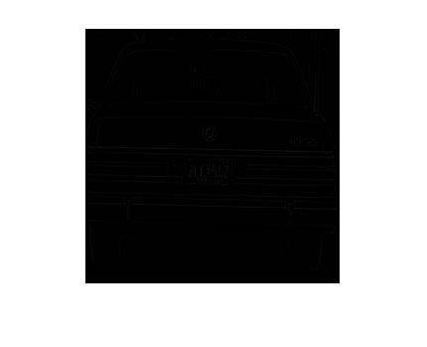

**B followed by A:**

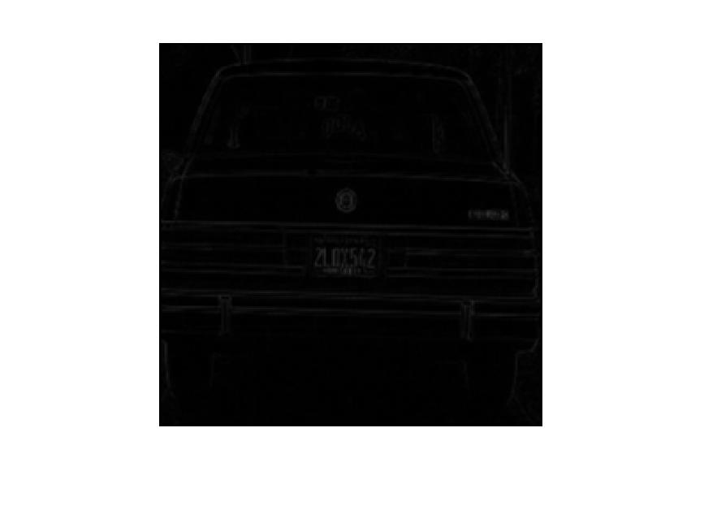

**Your comments:**

**Question 2(d):**

**Extended kernels of A and B (5x5):**

**Results obtained by applying 5x5 kernel:**

**B followed by A**

**A followed by B**

**A followed by A**

**Extended kernels of A and B (7x7):**

**Results obtained by applying 7x7 kernel:**

**A followed by A**

**B followed by A**

**A followed by B**

**Your comments:**

**Question 3(a):**

**Two non-consecutive frames:**

Image 1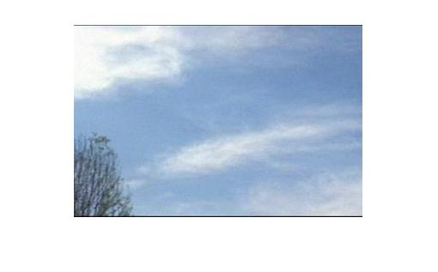

Image 2

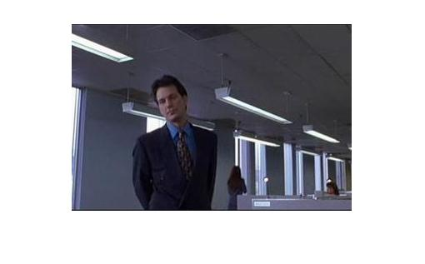

**Corresponding colour histograms:**

Histogram 2

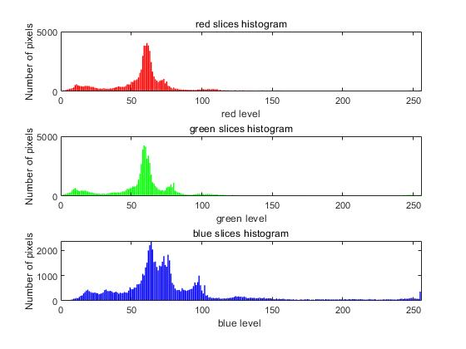

Histogram 1

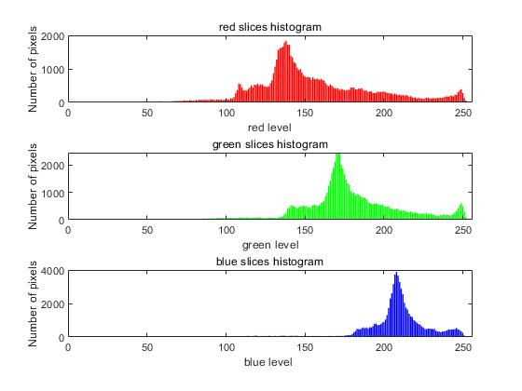

**Your comments:**

**Question 3(b):**

**Example 1:**

It

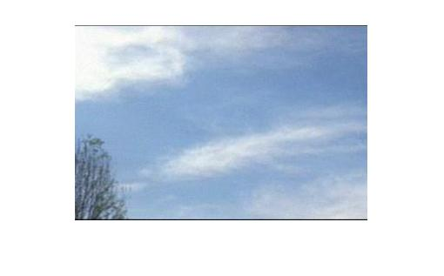

Frame3

It+1

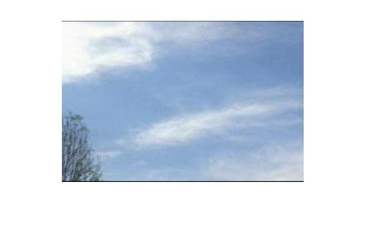

Frame4

**Histograms:**

Histogram of It

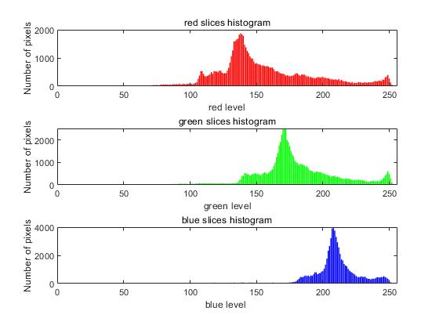

Histogram of It+1

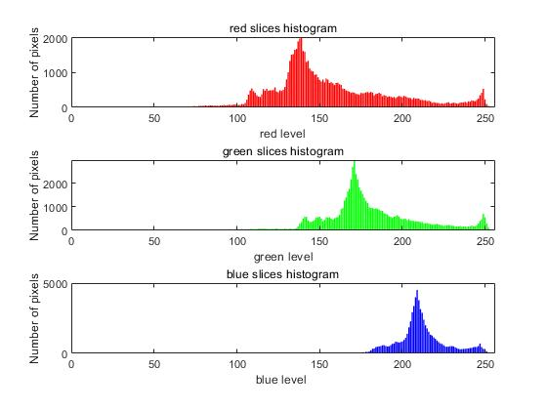

Intersection result

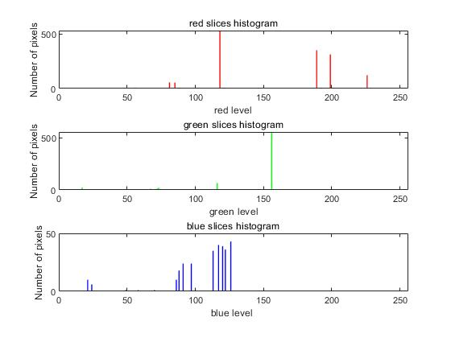

**Example 2:**

It+1

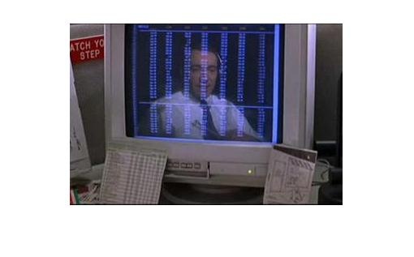

Frame10

It

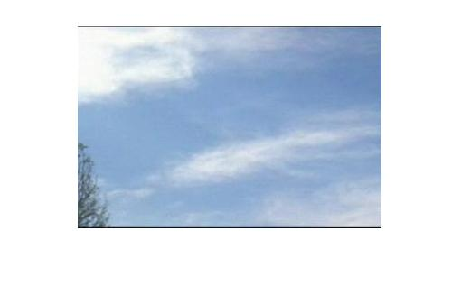

Frame9

**Histograms:**

Histogram of It

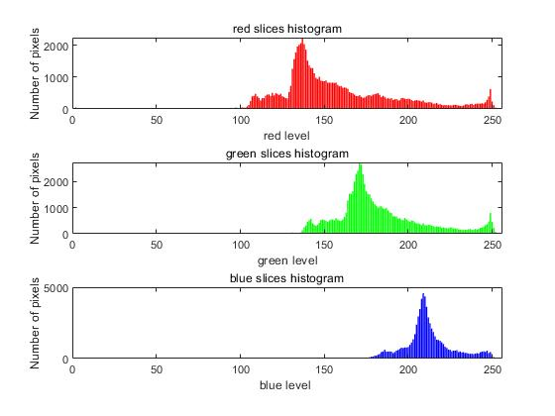

Histogram of It+1

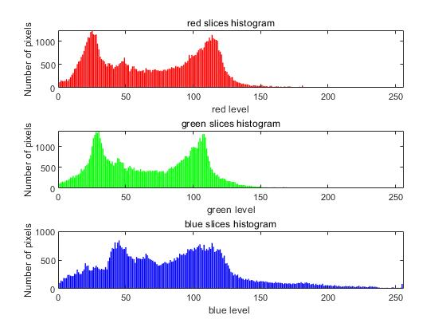

Intersection result

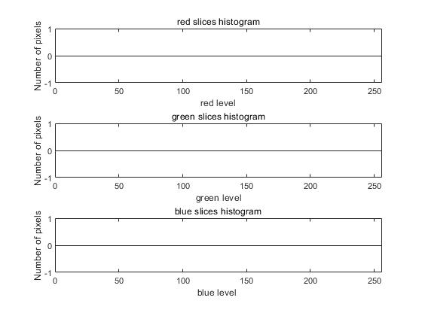

**Your Comments:**

**Question 3(c):**

**Comments:**

The intersection can be used to reprecent the scene changes in the video. As can be seen in the intersection histogram, there are no intersection value of the consecutive frames histograms (9th frame and 10th frame in DatasetB.avi). The intersection histogram can not show the location of each colors. However, it represented that the two frames RGB levels differnece and the amount of distributed color values. If there are no value in consecutive frames intersection histogram, the scene might be changed.